2025
General Election at a Glance

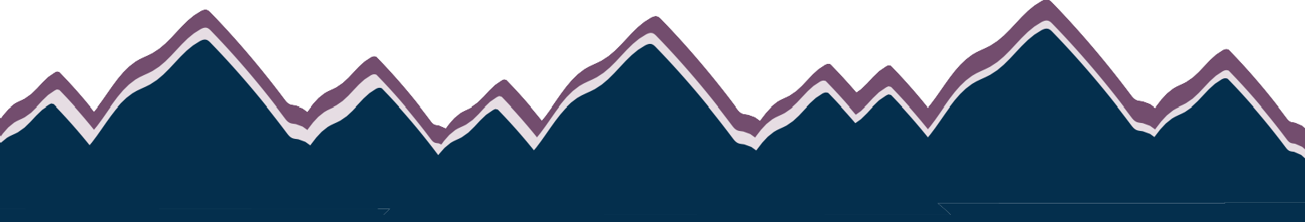
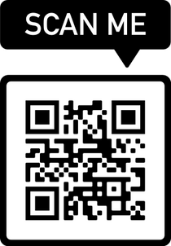


October 14
Ballots Mailed

Oct 24 at 5 p.m.
Last day to register to receive a by-mail ballot.

132,188

Active Registered Voters as of 9/18/25

30%

Projected Turnout
Voter registration, visit vote.utah.gov
In-Person Voting

When: Oct 28 - 31 Noon - 6 p.m.
Where:
Weber Center Basement Level
2380 Washington Blvd.
Ogden, UT 84401

Election Day Nov 4

7 a.m. - 8 p.m.
Weber Center Basement Level
2380 Washington Blvd.
Ogden, UT 84401
Ogden Valley Branch Library
131 S. 7400 E.
Huntsville, UT 84317
Ways to vote

Secure Ballot Dropbox, found at all city offices, county libraries & Weber State University.
By mail, Ballot must be received by the election office by 8 p.m. on Nov 4.
In person
In-person voters will be issued a paper replacement ballot and envelope.

Farr West Mayor
David P. Bolos
WHAT'S ON THE BALLOT

Ken Phippen
Farr West Council At-Large
Katie April Williams Jason James Anderson
Harrisville Mayor Roger W. Shuman Michelle Tait
Harrisville Council At-Large
Brenda Nelson Greg Montgomery
Steven Wayne Hempel Jason Hadley
Hooper Council District 1
Larry Ropelato Amanda Prince
Hooper Council District 2
David Lee Craig
Matthew Kilts-WITHDRAWN
Hooper Council District 3
Debra Marigoni
Ray Hancock Hancock
Huntsville Town Council At-Large
Jeff Keeny James A. Truett Sandy Hunter
Marriott-Slaterville Mayor
Les Syme
Mark G Hodson
North Ogden Mayor
Ryan M. Barker Phil Swanson
North Ogden Council At-Large
Kevin Burns Tera Carney Zach Ward Jay D Dalpias
Ogden Council At-Large A
Alicia Washington Marcia White
Ogden Council At-Large B
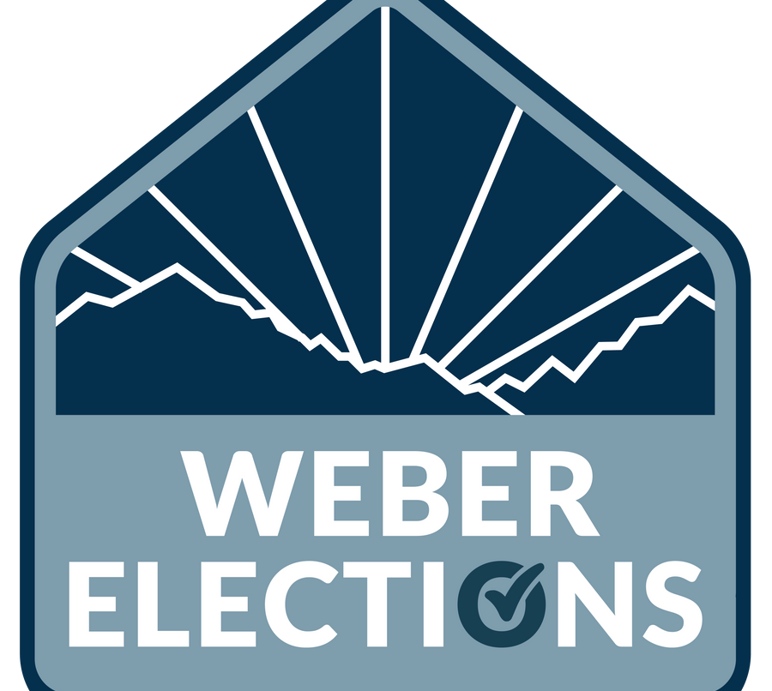
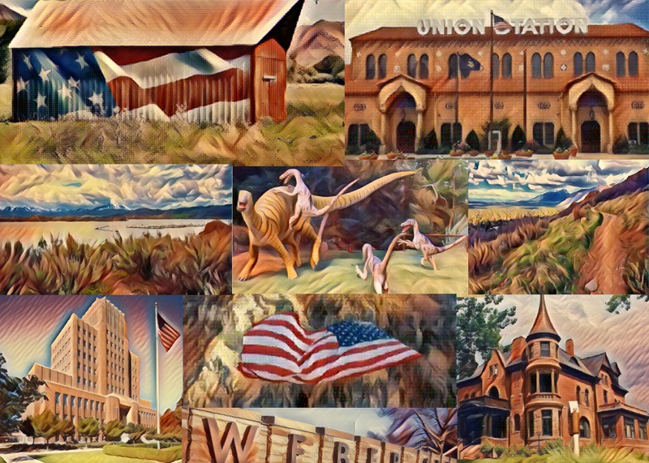
Bart E. Blair Kevin Lundell

VISIT WEBERELECTIONS.GOV TO LEARN MORE
For candidate information visit: vote.utah.gov
2380 Washington Blvd Suite #320 Ogden,
UT 84401
elections@weberelections.gov (801) 399-8034
Ogden Council Seat 1
Jase Reyneveld Flor Lopez
Ogden Council Seat 3
Ken R. Richey Heath Satow
Ogden Valley Mayor Janet Wampler Shanna Francis
Douglas James Dickson- WRITE-IN
Ogden Valley Council Dist. 1
Chelsea J Argyle Tia V Shaw
Ogden Valley Council Dist. 2
Abe Kelly Wangsgard Peggy Dooling-Baker
Ogden Valley Council Dist. 3
Fred W. Blickle, III Kay Hoogland
Ogden Valley Council Dist. 4
Chad Booth Laura Warburton
Ogden Valley Council Dist. 5
Don Hickman Dan Davenport
Plain City Mayor Phil F. Meyer Shawna Faulkner
Plain City Council At-Large
Jed Jenkins Sean Jones
Robert Jenkins Lamb Luigi Panunzio
Pleasant View Mayor
Steven Gibson Sara B. Urry
Pleasant View Council At-Large
Sean Wilkinson Brian Gray Johnny Ferry Derek Draper
Riverdale Mayor
Braden D. Mitchell Riverdale Council At-Large Kent T. Anderson
Bart Stevens
Shauna Flinders Stacey E Haws
Riverdale Council At-Large
Anne K. Hansen
Roy Mayor
Ann Marinda Jackson Mike J Vanalfen
Roy Council At-Large 4-yr
Diane Wilson Jason Evan Sphar Janel Hulbert Anthony W. Dick
Roy Council At-Large 2-yr
Alexis Jackson Randy R. Scadden
Uintah Mayor
Kristi Lee Bell
Uintah Council At-Large Michelle H. Roberts Benjamin R. Mitchell John Teague Sorenson
West Haven Mayor Austin Daniel Slaughter Rob Vanderwood
West Haven Council At-Large
Ryan Swapp Ryan Saunders Brad Smith
*Special Districts Candidates not listed

*Not all races are on all ballots, each voter receives only the races they are eligible to vote on.

